Laboratory Report: Natural Language Processing (ECL 545)
Department of Electronics and Communication Engineering
Visvesvaraya National Institute of Technology

Name: Shubhankar Bagchi, V Sadasiva Rao, MD Deen Ul Haq
Roll Number: MT24AAC006, MT24AAI168, MT24AAI166
Course: ECL 545: Natural Language Processing
Date: 09 May 26

1. Abstract
This project develops a deep learning-based system to classify news into two categories: fake and real. Using a fake news dataset, the project employs a Bidirectional Long Short-Term Memory (Bi-LSTM) network to process both Hindi and English text. The final model provides automated predictions with associated probability scores and simplified explanations to help users distinguish between accurate information and misleading claims.
2. Introduction
The proliferation of misinformation can have significant implications. This project aims to build a classifier that validates news text provided by the user. By leveraging Natural Language Processing (NLP) techniques such as tokenization, sequence padding, and recurrent neural networks, the system identifies patterns indicative of credible or fraudulent reports in a bilingual (Hindi and English) context.
3. Method/Procedure
The development process followed these technical stages:
- Data Preprocessing: Text was converted to lowercase, and regular expressions were used to remove URLs. A specific filter was applied to retain only alphanumeric characters and Hindi script characters (\u0900-\u097F).
- Text Vectorization: A Tokenizer was used to manage a vocabulary of 15,000 words. Sentences were converted into sequences and padded to a fixed length of 250 tokens.
- Model Architecture: A Sequential model was built using an Embedding Layer (128-dim), a Bidirectional LSTM (64 units), and a Dropout layer (0.5) to prevent overfitting, ending with a Softmax layer.
- Training: The model was trained using the Adam optimizer and cross entropy loss for 5 epochs.

4. Results
- Model Performance: The training script generates evaluation metrics such as a classification report and a confusion matrix to assess accuracy across the three target classes.
- Prediction Output: The system outputs the predicted label along with the specific probability for each class (fake and real).
- Explainability: The model successfully maps predictions to user friendly explanations, flagging misleading news when official sources do not support a claim.
5. Discussions
The use of Bi-LSTM layers is critical because news often contains long term dependencies where the meaning depends on both early and late context. The inclusion of Hindi character support ensures the model is applicable to the Indian media landscape. Challenges include handling the bilingual nature of the data and ensuring the dataset path is correctly configured in the runtime environment.
6. Conclusions
The project demonstrates a robust framework for bilingual news classification using deep learning. By combining automated prediction with "understanding" (simplified explanations), the tool bridges the gap between complex NLP outputs and practical user needs. Future work could involve implementing an attention mechanism to further improve classification accuracy.
7. Appendices
The project utilizes the following core Python libraries:
- Pandas & NumPy: For data manipulation.
- Scikit-learn: For data splitting and performance evaluation.
- TensorFlow/Keras: For building and training the Bi-LSTM neural network.

8. Code
import pandas as pd
import numpy as np
import re
from sklearn.model_selection import train_test_split
from sklearn.preprocessing import LabelEncoder
from tensorflow.keras.preprocessing.text import Tokenizer
from tensorflow.keras.preprocessing.sequence import pad_sequences
from tensorflow.keras.models import Sequential
from tensorflow.keras.layers import Embedding, LSTM, Dense, Dropout, Bidirectional

# Datasetloading

df = pd.read_csv("fake_news_dataset.csv")
df
title | text | date | source | author | category | label
0 | Foreign Democrat final. | more tax development both store agreement lawy... | 2023-03-10 | NY Times | Paula George | Politics | real
1 | To offer down resource great point. | probably guess western behind likely next inve... | 2022-05-25 | Fox News | Joseph Hill | Politics | fake
2 | Himself church myself carry. | them identify forward present success risk sev... | 2022-09-01 | CNN | Julia Robinson | Business | fake
3 | You unit its should. | phone which item yard Republican safe where po... | 2023-02-07 | Reuters | Mr. David Foster DDS | Science | fake
4 | Billion believe employee summer how. | wonder myself fact difficult course forget exa... | 2023-04-03 | CNN | Austin Walker | Technology | fake
... | ... | ... | ... | ... | ... | ... | ...
19995 | House party born. | hit and television I change very our happy doo... | 2024-12-04 | BBC | Gary Miles | Entertainment | fake
19996 | Though nation people maybe price box. | fear most meet rock even sea value design stan... | 2024-05-26 | Daily News | Maria Mcbride | Entertainment | real
19997 | Yet exist with experience unit. | activity loss very provide eye west create wha... | 2023-04-17 | BBC | Kristen Franklin | Entertainment | real
19998 | School wide itself item. | term point general common training watch respo... | 2024-06-30 | Reuters | David Wise | Health | fake
19999 | Offer chair cover senior born. | remain pressure glass me six senior though nor... | 2024-01-24 | Daily News | James Peterson | Health | fake
20000 rows × 7 columns

# Preprocessing ( Hindi & English )

def clean_text(text):
text = str(text).lower()
text = re.sub(r'http\S+', '', text) # links removal
text = re.sub(r'[^a-zA-Z0-9\u0900-\u097F\s]', '', text) # Hindi + English
return text

# Apply cleaning to the existing 'text' column
df['text'] = df['text'].apply(clean_text)

# Install NLTK if not already installed
!pip install nltk
import nltk
nltk.download('stopwords')
from nltk.corpus import stopwords

# Define English stop words
stop_words = set(stopwords.words('english'))

# Encoding

label_encoder = LabelEncoder()
df['label'] = label_encoder.fit_transform(df['label']) # Lable column is converted into 1s and 0s
# Split data into training and testing sets
X_train, X_test, y_train, y_test = train_test_split(
df_filtered['text'], df_filtered['label'],
test_size=0.2,
stratify=df_filtered['label'], # to divide our true and false labels equally amongst the splits
random_state=42
)
print(df_filtered['label'].value_counts())

# Tokenization

max_words = 15000
max_len = 250

tokenizer = Tokenizer(num_words=max_words, oov_token="<OOV>")
tokenizer.fit_on_texts(X_train)

X_train_seq = tokenizer.texts_to_sequences(X_train)
X_test_seq = tokenizer.texts_to_sequences(X_test)

X_train_pad = pad_sequences(X_train_seq, maxlen=max_len, padding='post')
X_test_pad = pad_sequences(X_test_seq, maxlen=max_len, padding='post')

# Bi LSTM Model

model = Sequential()
model.add(Embedding(input_dim=max_words, output_dim=128, input_length=max_len))
model.add(Bidirectional(LSTM(64)))
model.add(Dropout(0.5)) # to prevent overfitting
model.add(Dense(64, activation='relu')) #Activation function for hidden layers is relu
model.add(Dense(2, activation='softmax')) # fake, real ---> classification into 2 outcomes
model.compile(
loss='sparse_categorical_crossentropy', #loss function -> cross entropy
optimizer='adam', #optimiser to update weights
metrics=['accuracy']

# Train model

history = model.fit(
X_train_pad,
y_train,
epochs=5, # Increased epochs to improve learning
batch_size=32,
validation_split=0.2
)
# Evaluation/ Testing

loss, acc = model.evaluate(X_test_pad, y_test)
print("Test Accuracy:", acc)

y_pred = model.predict(X_test_pad)
y_pred_classes = np.argmax(y_pred, axis=1)

print(classification_report(y_test, y_pred_classes))
print(confusion_matrix(y_test, y_pred_classes))

import matplotlib.pyplot as plt
import seaborn as sns

cm = confusion_matrix(y_test, y_pred_classes)

plt.figure(figsize=(8, 6))
sns.heatmap(cm, annot=True, fmt='d', cmap='Blues', xticklabels=['Fake', 'Real'], yticklabels=['Fake', 'Real'])
plt.xlabel('Predicted Label')
plt.ylabel('True Label')
plt.title('Confusion Matrix')
plt.show()

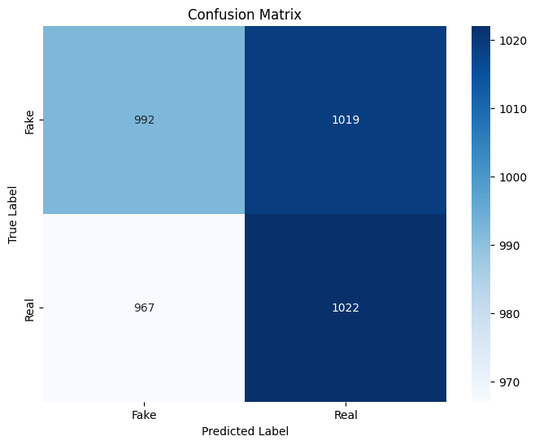

def predict_with_explanation(text):

cleaned = clean_text(text)
seq = tokenizer.texts_to_sequences([cleaned])
pad = pad_sequences(seq, maxlen=max_len, padding='post')

pred = model.predict(pad)[0]

# Explicitly define mapping from model output (0 or 1) to string labels
# Assuming 0 is 'fake' and 1 is 'real' based on model comments
class_names = {0: 'fake', 1: 'real'}

# Create probabilities dictionary for the two relevant classes
probabilities = {class_names[i]: float(pred[i]) for i in range(len(pred))}

# Get the predicted string label
predicted_label_index = np.argmax(pred)
predicted_label_string = class_names[predicted_label_index]

return predicted_label_string, probabilities
Civilian understanding

def simplify_explanation(text, label):

if label == "fake":
return "⚠️ This news appears misleading. Official government sources do not support this claim. It may be exaggerated or false."

elif label == "real":
return "✅ This news aligns with official government information. It is likely accurate."
def analyse_news(text):

label, probabilities = predict_with_explanation(text)

explanation = simplify_explanation(text, label)

print("\n🔍 Prediction:", label)
print("\n📊 Probabilities:")

for k, v in probabilities.items():
print(f"{k}: {v:.4f}")

print("\n🧠 Explanation:")
print(explanation)

# Testing of data

news_input = input("Enter news text: ")

analyse_news(news_input)

